|  |
| --- |
| Close-up image showing the leaf-sides of two oversized books side-by-side on a bookshelf, with additional books in soft focus background |
| DIGITAL ASSIGNMENT 1  CSE1007 / JAVA PROGRAMMING / GUI APPLICATION |
| |  |  |  | | --- | --- | --- | | ANISH SHRESTHA | 11/16/21 | 20BCE2893 | |

**DIGITAL ASSIGNMENT 1**

REGNO: 20BCE2893

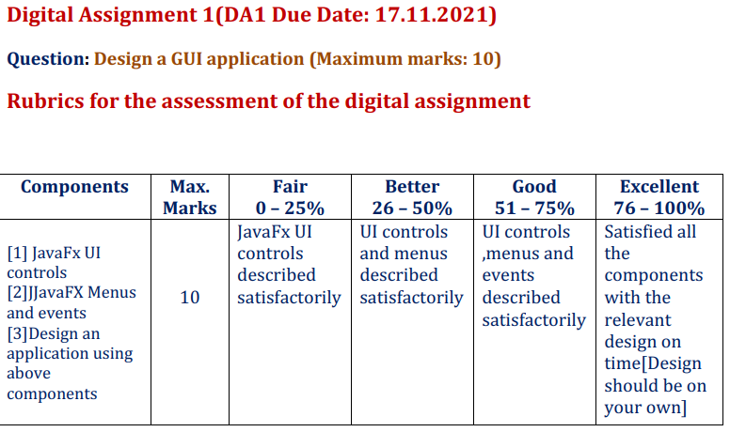

SIMPLE FAMILY FORM:

CONSIST OF : UI CONTROLS, MENUS AND EVENTS

|  |  |  |
| --- | --- | --- |
| EVENT | WORK | BUTTON |
| Action Event (Event) | Clear the form | (Menu item) clear |
| Action Event (Action Event) | Takes all values of form and update to mysql database | Submit button |
| OnMouseClick | Green background color changes in submit button | Submit button |

Code:

import javafx.application.Application;

import javafx.event.ActionEvent;

import javafx.event.EventHandler;

import javafx.scene.Scene;

import javafx.scene.SubScene;

import javafx.scene.input.MouseEvent;

import javafx.scene.control.*;

import javafx.scene.paint.Color;

import javafx.scene.shape.Circle;

import javafx.scene.text.Font;

import javafx.scene.text.Text;

import javafx.stage.Stage;

import java.sql.Connection;

import java.sql.DriverManager;

import java.sql.Statement;

import javafx.geometry.Pos;

import javafx.scene.layout.BorderPane;

import javafx.scene.layout.GridPane;

import javafx.scene.layout.VBox;

import java.time.format.DateTimeFormatter;

public class App extends Application {

    @Override

    public void start(Stage primaryStage) throws Exception {

        primaryStage.setTitle("simple form");

        BorderPane bordr = new BorderPane();

        MenuBar menubar = new MenuBar();

        Menu FileMenu = new Menu("File");

        MenuItem filemenu1 = new MenuItem("Form");

        MenuItem filemenu2 = new MenuItem("Clear");

        bordr.setTop(menubar);

        FileMenu.getItems().addAll(filemenu1, filemenu2);

        menubar.getMenus().addAll(FileMenu);

        Text txt = new Text("Name");

        txt.setFont(Font.font("Verdana", 20));

        txt.setStroke(Color.WHITESMOKE);

        TextField name = new TextField();

        Text txt1 = new Text("Relationship");

        txt1.setFont(Font.font("Verdana", 20));

        txt1.setStroke(Color.WHITESMOKE);

        ChoiceBox relation = new ChoiceBox();

        relation.getItems().addAll("Wife", "Father", "Mother", "Sister", "Brother", "Grandpa", "Grandma", "Son",

                "Daughter");

        Text txt2 = new Text("DOB");

        txt2.setFont(Font.font("Verdana", 20));

        txt2.setStroke(Color.WHITESMOKE);

        DatePicker dob = new DatePicker();

        Text txt3 = new Text("Favourite color");

        txt3.setFont(Font.font("Verdana", 20));

        txt3.setStroke(Color.WHITESMOKE);

        ChoiceBox choiceBox1 = new ChoiceBox();

        choiceBox1.getItems().addAll("red", "Black", "Blue", "Yellow", "Green", "Gray", "Silver");

        Text text3 = new Text("Favourite_Place");

        text3.setFont(Font.font("Verdana", 20));

        text3.setStroke(Color.WHITESMOKE);

        ChoiceBox box = new ChoiceBox();

        box.getItems().addAll("Kashmir", "Haryana", "Mumbai", "Jaipur", "Delhi", "Vellore");

        Text text4 = new Text("Phone Number");

        text4.setFont(Font.font("Verdana", 20));

        text4.setStroke(Color.WHITESMOKE);

        TextField phone = new TextField();

        Text text5 = new Text("Favourite food");

        text5.setFont(Font.font("Verdana", 20));

        text5.setStroke(Color.WHITESMOKE);

        TextField textField1 = new TextField();

        Text text6 = new Text("Your Dream");

        text6.setFont(Font.font("Verdana", 20));

        text6.setStroke(Color.WHITESMOKE);

        TextField dream = new TextField();

        Button button1 = new Button("Submit");

        button1.setShape(new Circle(50));

        button1.setOnMouseClicked(new EventHandler<MouseEvent>() {

            @Override

            public void handle(MouseEvent mouseEvent) {

                button1.setStyle("-fx-background-color: green; -fx-text-fill: white;");

            }

        });

        ((MenuItem) filemenu2).setOnAction(new EventHandler<ActionEvent>() {

            @Override

            public void handle(ActionEvent Event) {

                name.clear();

                phone.clear();

                textField1.clear();

                dream.clear();

            }

        });

        button1.setOnAction(new EventHandler<ActionEvent>() {

            @Override

            public void handle(ActionEvent actionEvent) {

                String n1 = name.getText();

                String n2 = (String) relation.getValue();

                String n3 = dob.getValue().format(DateTimeFormatter.ofPattern("yyyy-MM-dd"));

                String n4 = (String) choiceBox1.getValue();

                String n5 = (String) box.getValue();

                String n6 = phone.getText();

                String n7 = (String) textField1.getText();

                String n8 = (String) dream.getText();

                System.out.println(n1);

                System.out.println(n2);

                System.out.println(n3);

                System.out.println(n4);

                System.out.println(n5);

                System.out.println(n6);

                System.out.println(n7);

                System.out.println(n8);

                try {

                    Class.forName("com.mysql.cj.jdbc.Driver");

                    String url = "jdbc:mysql://localhost:3306/javafx";

                    String username = "root";

                    String password = "";

                    Connection con = DriverManager.getConnection(url, username, password);

                    String query = "insert into anish20bce2893 values('" + n1 + "','" + n2 + "','" + n3 + "','" + n4

                            + "','" + n5 + "','" + n6 + "','" + n7 + "','" + n8 + "');";

                    Statement stmt = con.createStatement();

                    stmt.executeUpdate(query);

                    System.out.println("success");

                    con.close();

                } catch (Exception e) {

                    System.out.println("Exception !! be careful");

                }

            }

        });

        GridPane pane = new GridPane();

        pane.setVgap(10);

        pane.setHgap(10);

        pane.setAlignment(Pos.CENTER);

        pane.addRow(0, txt, name);

        pane.addRow(1, txt1, relation);

        pane.addRow(2, txt2, dob);

        pane.addRow(3, txt3, choiceBox1);

        pane.addRow(4, text3, box);

        pane.addRow(5, text4, phone);

        pane.addRow(6, text5, textField1);

        pane.addRow(7, text6, dream);

        pane.addRow(8, button1);

        pane.setStyle("-fx-background-color: #015a57");

        SubScene subone = new SubScene(bordr, 400, 20);

        SubScene subtwo = new SubScene(pane, 600, 600);

        VBox root = new VBox(10);

        root.getChildren().addAll(subone, subtwo);

        Scene scene = new Scene(root, 600, 600);

        primaryStage.setScene(scene);

        primaryStage.show();

    }

    public static void main(String[] args) {

        launch(args);

    }

}

Output:

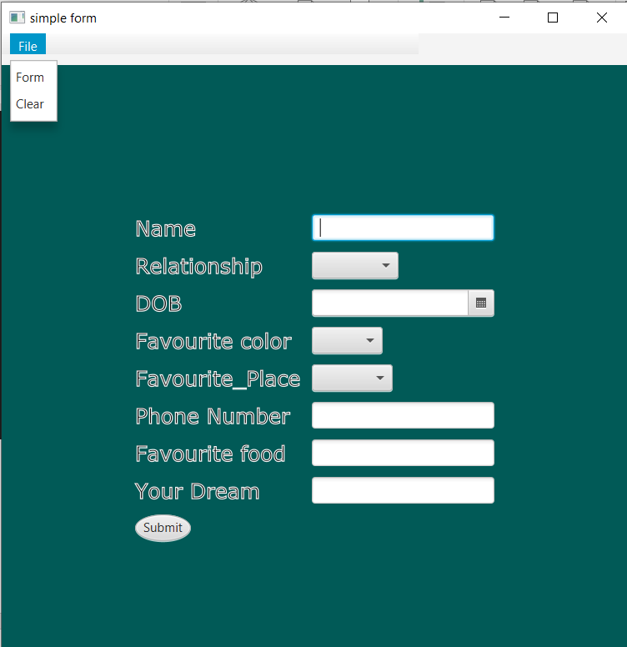

When submit the button goes green…

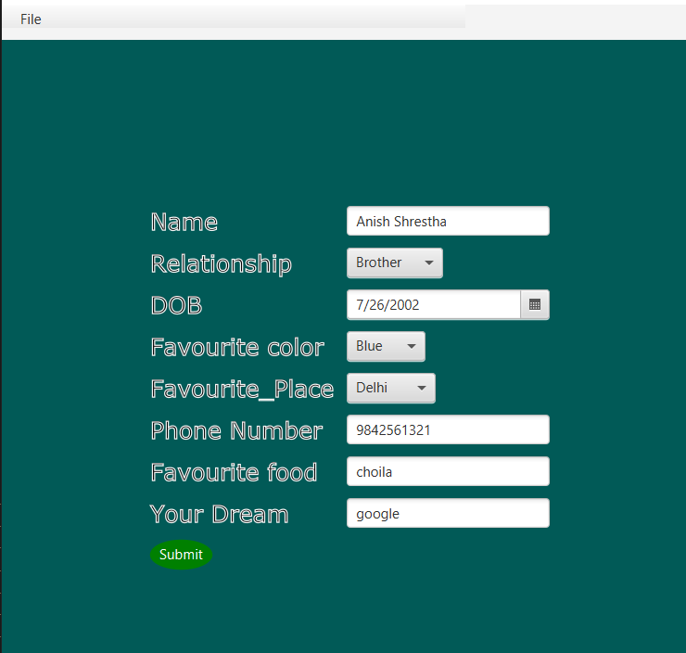

Console after submission:

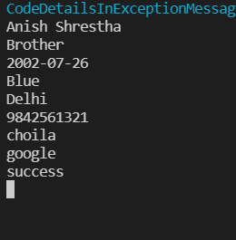

Store in my sql database (xampp used)

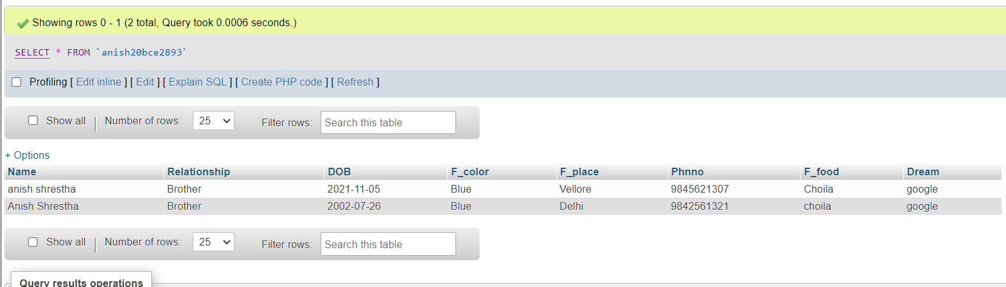

Two queries were updated…

Clear button clears the text field..

